Homework 1: Crypt Basics

1. The key to the ciphertext is “SUNTZU.” This was found using a python script by first determining the key length by searching throughout the entire text for copies of three letters together. Through this the length of the ciphertext was found to be either 3 or 6 letters long. From this a frequency analysis can be done on both key lengths to find the letters in the key. This can be done by finding the amount of each letter for each of the 6 key letters. From this, the key can be found by comparing the largest from each to the letter ‘e’ as this is the most frequent letter in the alphabet. This did not perfectly find the key, but through looking at the data to find other maximum values and comparing those to ‘e’, found a better solution in terms of the English dictionary words or names. After determining the key, I decrypted the ciphertext to reveal the plaintext to show that the key works as predicted.
2. 1. 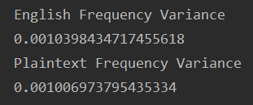
   2. 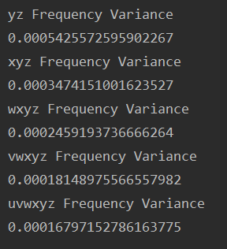

As the key gets longer, the variance of the letter frequency decreases in a sort of logarithmic way, and decreases away from the general letter frequency of the English language.

* 1. 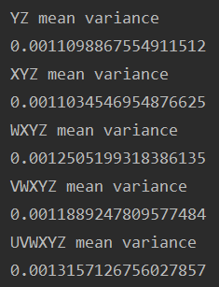

These mean variances are more like the variance of the English language frequencies than those found in part b. This is because of the lack of changing between letters, like the overall ciphertext would see. The frequencies of each individual Caesar cipher in the Vigenere cipher will be similar to the English language but when put together will be much different.

* 1. 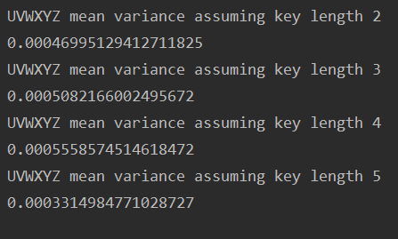

The values found with the correct key length are close to the variance for the English language. This explains why these values are not close to the values above, because the key length is off and has a much different variance due to the more random values found. This is how it is a variant of the Kasiski method, because the variance of the frequency of letter usage at different key lengths can be found and compared to the English language letter frequency with the closest one being the key length.

1. hehe